Australian Salers AGM 2018 24/25th of November Location - Mt Gambier SA
If you would like to attend the Australian Salers Tour and AGM please remember to do the following –
- Book your accommodation either at the Comfort Inn Silver Birch or at a facility of your choice.
  - (08) 8725 5122 Comfort Inn Silver Birch
- Advise the number of seats/days required on the bus and reserve your seats for tea at the South Eastern Hotel
  - Email Roz on r-curtis@bigpond.com if at all possible or
  - Roz on mobile 0433 511 659 after hours please.
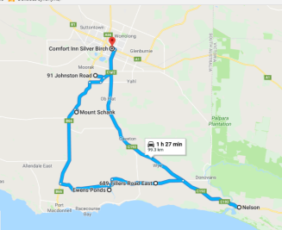
Note- Mt Gambier is about a five hour drive from either Adelaide or Melbourne so please allow enough time for traveling. Mt Gambier airport is about a 15minute car ride from the suggested accommodation. A taxi pick up can be organised from the airport.
Saturday 24th November (approx. 115 km travelled)
8.15 meet at motel Comfort Inn Silver Birch (near reception)
8.30 leave
8.45 arrive at 91 Johnston Rd OB Flat - Cara Park Salers
Paddock walk/stock inspection, morning smoko
11.00 leave Cara Park Salers
11.30 arrive Nelson/Donovans BBQ lunch
1.00 leave Nelson/Donovans
1.30 arrive Donovan’s Dairy 689 Tillers Rd Wye
To fit things in we unfortunately are not able to view a milking.
3.00 leave
3.15 arrive Ewens Ponds or Mt Schank picnic areas for afternoon smoko
4.00 leave
4.30 arrive back at Silver Birch Motel
5.30 pickup for AGM meeting
5.45 AGM meeting at Mt Gambier Show grounds - Presidents’ room
6.45 leave
7.00 tea South Eastern Hotel
One return trip only to the Silver Birch.
Sunday 25th November (200 km)
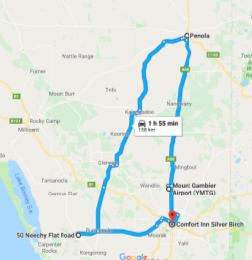
8.00 meet at Motel - Silver Birch
8.15 leave
8.45 Arrive Roy Mclean 50 Neechy Flat road Kongorong
Stock inspection
9.45 leave
10.00 arrive Tim Bowering 2390 Carpenters Rocks Road
Morning smoko
10.30 Stock inspection
12.00 leave
1.00 arrive Penola lunch – everyone pays for their own lunch
- Pub
- Café or bakery
  - A pre order menu will be given out in the morning and your order phoned through for you.
2.00 Either stay in town for a coffee, view the Mary Mackillop Centre, art galleries etc with a time given for a pick up
Or visit a couple of close wineries for wine tasting
4.00 leave Penola (may need to leave earlier if people fly out at 4.35 as they need to be at airport at 3.30 – leave Penola at 3)
4.30 at Mt Gambier airport for those departing
5.00 return to motel

Bio Security
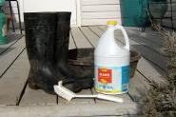
Could everyone please make sure their foot wear are as clean as possible before entering the bus to help with bio security on the next property. Thank you for your help with this.

Bus
As we are traveling approximately 300km over the weekend I have booked a mini bus for everyone’s comfort. The cost for a 2 day seat is $55. A one day seat is available at $30. Preference will be given to those who book a 2 day pass on a first in first served basis. To reserve a seat please contact Roz Curtis via email on r-curtis@bigpond.com or ph 08 87268162 /mobile 0433 511 659 after hours please.
Accommodation
There is a large array of accommodation in Mt Gambier to suit your requirements.
The Comfort Inn Silver Birch has been kind enough to give us corporate room rates and this is where the bus will pick you up and drop you off.
- $120 standard queen ) to receive this rate you need to book direct with the
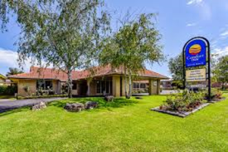
- $135 standard twin ) Silver Birch and say you are from the A.S.A.
- $155 triple room )
Comfort inn Silver Birch
Address: 96 Jubilee Hwy E, Mount Gambier SA 5290/ Cnr Morris and Jubilee Highway East
Phone: (08) 8725 5122

https://www.silverbirchmotel.com.au/
Within walking distance are a couple of other motels if the Silver Birch didn’t suit your accommodation requirements.
- Best Western Southgate Motel
- Red Carpet Motel
- Arkana Motor Inn and Terrace Apartments
- Plus others a bit further from the Silver Birch
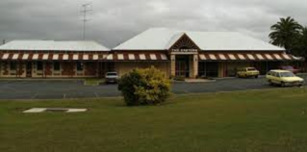
Saturday night Meal
A one minute car ride or a seven minute walk from the Silver Birch is the South Eastern Hotel where we will be having tea at 7.30pm.
To book a seat please contact Roz Curtis on 08 87268162 or mobile 0433 511 659 after hours please.
South Eastern Motel
Address: 235 Commercial St E, Mount Gambier SA 5290
http://www.matthewshotels.com.au/southeasternhotel/ if you want to see a menu

Property over views
Cara Park Salers
Cara Park Salers started as a lifestyle choice but this small scale Salers stud in the last few years has made some of the bigger studs at local shows sit up and take notice. Our aim is to breed moderate, beefy females of optimum temperament which then will produce quality 2 year old bulls for sale.

Donovans Dairy
Donovans Dairying Pty Ltd is owned by James and Robyn Mann who run 1,400-2,400 milking cows on 4,180 acres. These cows are milked twice daily on a 116 bale rotary dairy, milking 500 cows an hour. Donovans dairy calve down twice a year in August/September and February/March to maintain a continuous milk supply. Consequently they rear each year between 900-1000 heifers (to act as replacements for the herd) and a further 150-250 steer calves. For diversification James and Robyn also lamb down about 550 ewes in May/June.

Roy Mclean
I run a sheep and cross bred beef cattle enterprise at Kongorong. I want to breed easy calving robust animals to produce vealers and have a self-replacing female herd. I had read and heard about Salers having great mothering and easy calving capability so about 3-4 years ago I purchased my first Salers bull. I started breeding with Angus cross base cows and have bred up from there. I’m pleased with the Salers cross animals and I don’t have caving problems which is a major advantage.

Tim Bowering
We bought our first Salers bull back in 20014 to go over a line of xbred Herefords we had purchased and wanted to keep. People said the bull was too little to do the job (he was very young) but after a 5 week mating period the 18 heifers were all pregnant. These heifers calved with no problems, due to the calves small size but they grew quickly and the calves were sold off their mothers as vealers. Since then this bull has had regular small mobs of females so we now have about 5 calvings a year and when we don’t need him he is lent to neighbors. He has been a very busy boy with 100% conception rate. We have tried other breeds of bulls without much success so last year we purchased a further 2 Salers bull to further continue our cross breeding program.

The itinerary is subject to change due to weather or unforeseen circumstances but best endeavour will be made to run as close as possible to it. Please keep in contact with Roz if you are traveling independently in your own vehicle or running late.

