NSW Regional Report
Greetings to all from NSW. Like in many parts of Australia the seasons have been variable and challenging in the rural sector. Mother nature will do as she pleases.
Firstly we’d like to welcome Stephen Nicholas back into the fold this year. From previous years Steve has always been a good contributor of information and we look forward to his enlightening tales. A recent chat with Steve revealed that he is planning on showing cattle at seven regional shows and that he has been regularly having success in the show ring. I’m sure Steve will forward photos and details following these events.
Prices have also been variable over the year but good well-presented animals continue to attract a premium.
Neil & Kathy Gardner have been pleased with the overall quality of progeny resulting from the use of “Red Rock” semen. Not every animal has all the attributes that a breeder is looking for but the same may be said of using any AI sire or bull. Sometimes it clicks and sometimes you’re just left wondering!!!
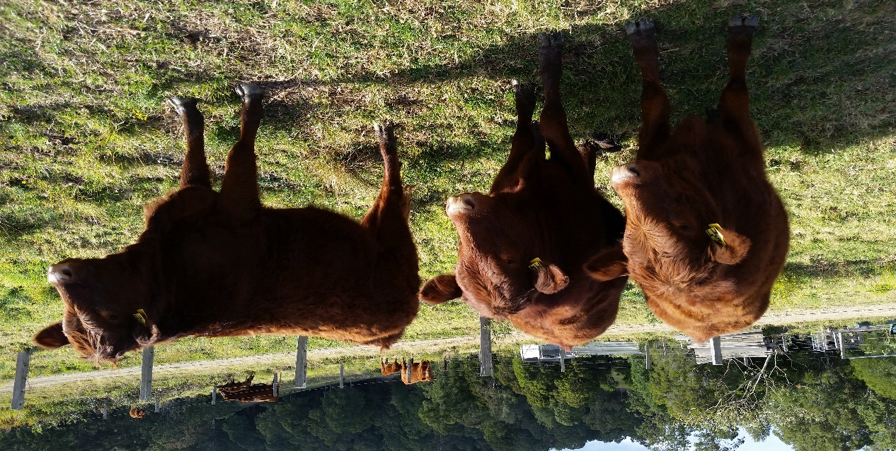
These 3 heifers – sired by “Red Rock” (not in their best dress or pose) averaged 400 kgs at 14months of age. They have continued to develop and now look pretty smart.
A couple of steers of the same drop weighed 500 Kg at 14 months with some supplementary feed but didn’t appear to have adequate fat cover to meet grid requirements and have been held over to sell as 2 yr. olds. It will be interesting to see their final weights.
Red Angus x Salers steers had no problem in meeting MSA requirements and sold at 12 ½ months with an average hot weight of 262Kg with fat coverage between 8 – 12 mm. Dress out percentage of 54% on pre curfew weight. We also sold a bull which dressed out at 58% of his non curfew weight and had an “A” Butt.
Feedback from previous purchasers continue to be favourable. Having repeat buyers is always good testimony that people are happy with the progeny produced from those purchased.
A reminder that if any member has any issues they wish raised at Council level please don’t hesitate to contact their state representative or president. Any good news stories are most welcome.

